
Autumn Term 1 2024

Welcome to Acorn parents and children! It has been a fantastic start to the year! The children have simply loved exploring their new classroom and, as a result, they have settled in beautifully. They arrive happy and ready to learn, which is wonderful to see. Our topic for this half term is ‘Marvellous Me.’ You will find an outline of planning on the back of this sheet.

Afternoon snack
Snack and milk will be provided by the school in the mornings. Please can all children bring in a healthy snack to have in the afternoon.

P.E.
P.E. will be on every Wednesday, please send your child into school in their PE kit. All children will start PE on Wednesday 18th September.

Presentations
Children will have the opportunity to present to their peers on a topic of their choosing. The presentation needn’t last longer than 5 minutes and can include props, images, video clips or powerpoint slides. Over the course of their time at school, we will be helping children learn the skills needed to speak with confidence and authority on subjects they are passionate about. All children will be given a specific date once the children are settled.

Reception Baseline Assessment
Children will be completing the statutory Reception Baseline Assessment. This will provide information on their language, communication and literacy as well as early mathematical knowledge. This is an activity-based assessment which needs to be completed within the first 6 weeks of starting school. The assessment will begin next week.

Tapestry
After the first two weeks all parents will be sent an email from Tapestry for you to set up your account for Tapestry. Once activated you will be able to see all the wonderful things your child is learning and involved in at school. You are also able to upload any photos or observations of your child whilst at home!

Name labels
Please, please, please make sure everything is labelled! We’re sure you can appreciate that with 25 small children, all in matching clothes, it can be difficult to keep track of belongings so names on all items would be much appreciated. Thank you to those of you who have already labelled everything.

Spare clothes and wellies
Please can all children bring in some named spare clothes to keep in their individual box. Children will have access to water, sand, malleable resources so may on occasion get a little wet or messy. All children will also need a pair of named wellies, we will be going on wellie walks and visiting Forest School.

Collection
To ensure the safety of all children, I kindly request you review your child’s Arbor account and add any additional adults to indicate who is able to collect. If it is a one off collection, please ensure you have spoken to a member of Acorn class staff or email the school office; without consent we will not be able to let your child leave.

Drop off and pick up
From Monday 9th September please can all children be dropped off at the Reception gate. We are encouraging all children to be independent in coming into school on their own. At pick up time all parents are welcome to come into the Reception playground to pick up. Thank you for your support and cooperation.

With best wishes,
Mrs Long

Ruishton C of E School Autumn 1 Acorn Class

Mathematics

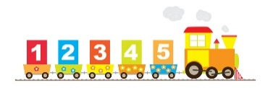

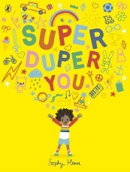

Our class focus texts this term are ‘Super Duper You’ by Sophy Henn. We will also look at ‘Incredible you!’ by Rhys Brisenden and ‘The Colour Monster’ by Anna Llenas to support our topic.
Throughout the Autumn term, the children will start to learn phonics through our RWI phonics scheme.
Developing children’s communication and language skills is at the heart of everything that we do in Reception. We provide open-ended resources and opportunities for collaborative play, as well as role play and small world areas, which enhance children’s speaking and listening skills.

This term Acorn Class will be focusing on refining the children’s subitising and counting skills and ensuring that they can understand the value of numbers. We are already noticing that the children enjoy counting and we will be helping them to secure in their counting to 10 and understanding how numbers to 10 work (number sense).
There will be lots of opportunities for the children to apply their understanding of number value in the classroom through various concrete and visual resources. We will also be having lots of ‘real-life’ experiences so children can use their mathematical knowledge in real situations.

We will be experimenting with a variety of resources throughout our daily provision to explore colour, line and shape.

We will also invent and adapt narratives and stories with peers during role play.

Our value this term is ‘Responsibility’.
We will ask…
- Who am I?
- Where do I belong?
- How do I respect God’s creations?
Will be also think about special places and special people in our lives.

Communication, Language and Literacy

Expressive Arts and Design

This term, our theme across the trust is ‘Science and Technology.’
We will be looking closely at the world around us and talking about the changes we can see in the outside environment. We will talk about changing colours and explore different ways of making this happen. For Harvest, we will learn about food from the farm to the table. We will be doing cooking and learning songs about Harvest, discussing healthy foods and encouraging this in our lunch boxes. We will also focus on the human body.

We will also ask the questions:
- Why does Easter matter to Christians?
- What is the good news that Jesus brings?
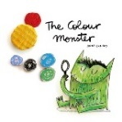
Personal, Social and Emotional Development
MARVELLOUS ME!
This term, we will be thinking about;
- Friendship
- Kind and gentle hands
- Our rights and responsibilities
- Feelings and emotions- How we can be safe and happy at school
The important focus for us this half term is making sure that all the children are settled, happy and ready to learn. We will be following the Jigsaw unit ’Being me in my world’ which teaches children about respecting others’ feelings and problem solving. Sharing and turn taking will be practised through small group games and modelled by adults. The children will then be able to apply these skills to their future learning experiences.

Understanding the World
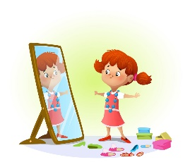


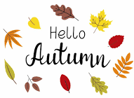
We will be developing our fine motor skills through weaving, pencil control and threading activities. We will also focus on key skills such as hopping, skipping and jumping in PE to develop our gross motor skills and coordination.

Physical Development

Faith & Belief

